BASIC EDUCATION STUDENTS’ ASSOCIATION
WEBSITE MANUAL

MAIN PAGE FEATURES
NB: MOST OF THESE FEATURES APPEAR IN ALL WEBPAGES
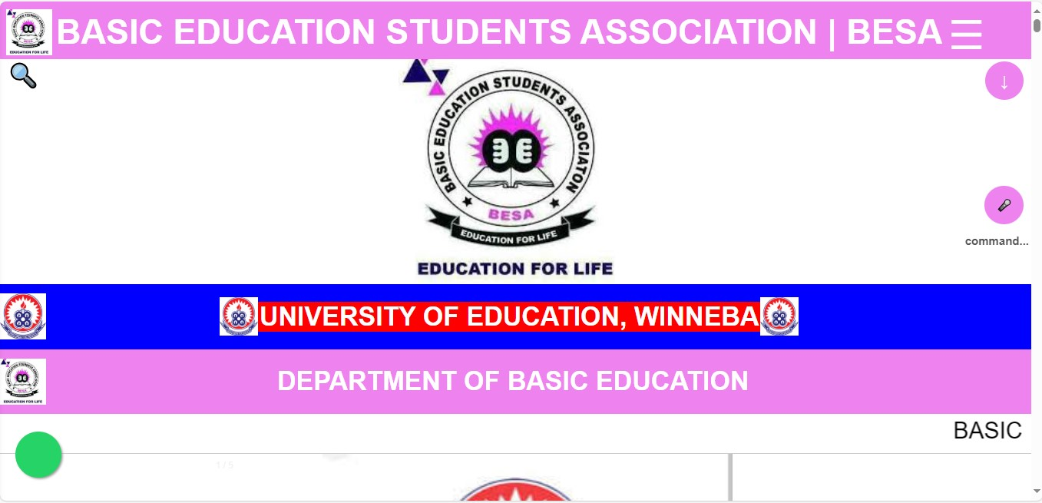
SCROLL DOWN
MOVE DOWN OR BOTTTOM OF THE WEBPAGE
HAMBURGER MENU
CONTAINS HYPERTEXTS TO OTHER WEBSITES AND WEBPAGES.
SEARCH ICON:
TO SEARCH FOR INFORMATION ON THE WEBSITE
WHATSAPP
SHARE WEBSITE LINK TO WHATSAPP
VOICE CONTROL
CONTROL THE WEBPAGE TO MOVE UP, HALF AND DOWN. SAY; UP: TO MOVE UP, HALF: TO MOVE HALF, AND DOWN: TO MOVE DOWN.
SAY FAST OR SLOW TO INCREASE OR DECREASE THE SCROLL SPEED

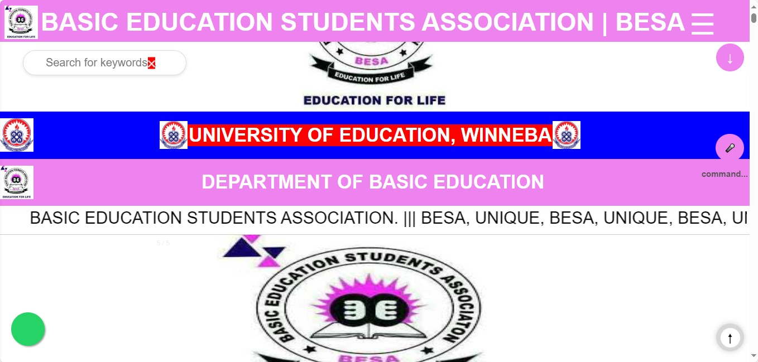
SEARCH INPUT:
CLICK ON THE SEARCH ICON TO OPEN THE SEARCH INPUT TO SEARCH
SCROLL UP
MOVE UP OR TOP OF THE WEBPAGE
MENU CONTENTS
ACCESS ALL PAGES HERE, INCLUDING LINKS TO OTHER WEBSITES AND DEPARTMENTAL HANDLES
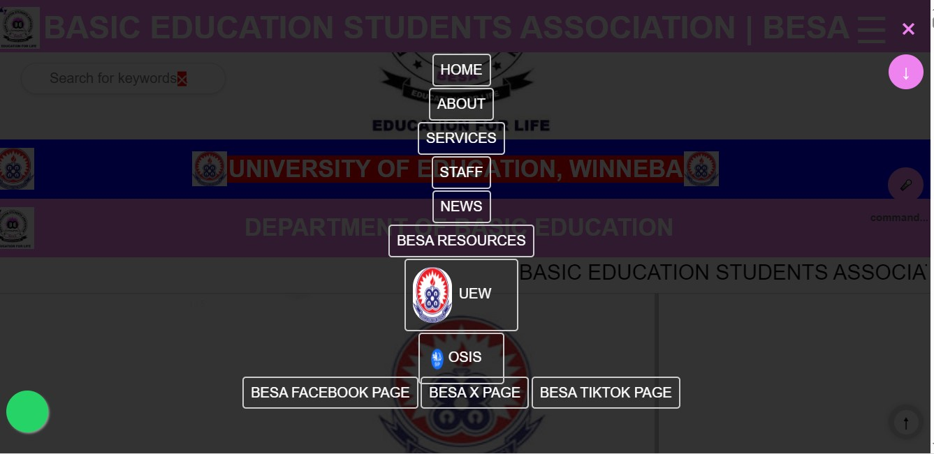
CLOSE MENU
USE THE CLOSE BUTTON TO CLOSE THE HUMBURGER MENU

NB: MOST IMAGES ON THE WEBSITE ARE CLICKABLE, SHAREABLE AND DOWNLOADABLE
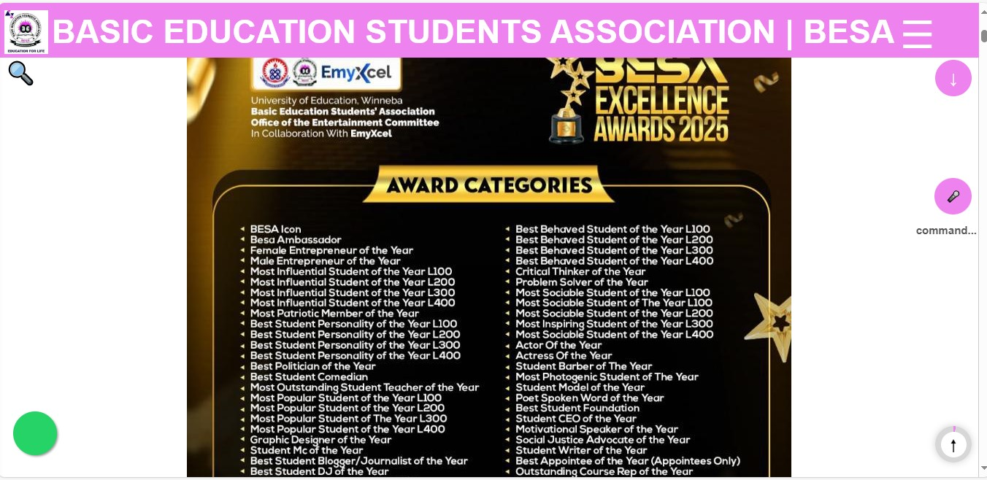
YOU CAN CLICK ON ANY IMAGE ON THE PAGE TO VIEW IT. MOST IMAGES ARE CLICKABLE.
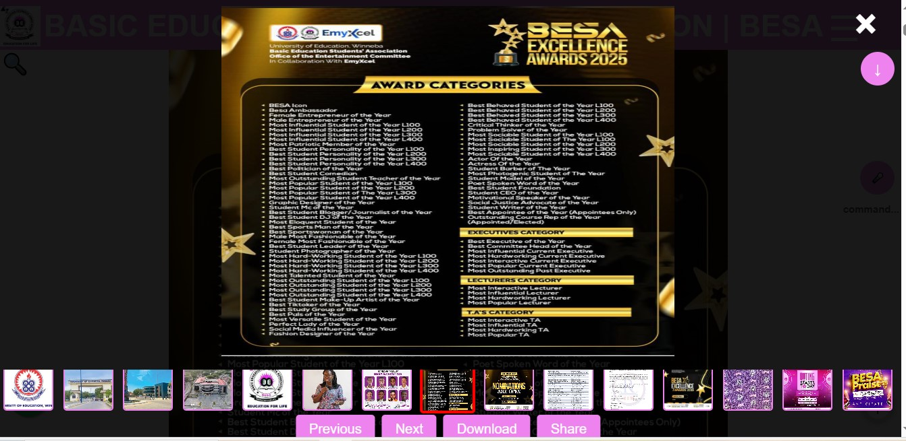
MINI-IMAGE
WHEN YOU CLICK ON AN IMAGE, IT SELECTS IT, YOU CAN VIEW OTHER MINI-IMAGES ON THE WEBSITE. THEY CAN ALL BE CLICKED ON AND VIEWED, AND ALSO BE SCROLLED TO THE LEFT OR RIGHT
IMAGE FEATURES
YOU CAN USE THEM BY CLICKING ON THEM.
IMAGE
WHEN YOU CLICK ON ANY IMAGE ON THE WEBPAGES IT OPENS.
CLOSE IMAGE
USE THE CLOSE BUTTON TO CLOSE THE IMAGE

YOU CAN SWITCH TO LIGHT MODE, DARK MODE AND COLOURFUL MODE ON THE WEBSITE. LIGHT IS DEFAULT, NOTHING CHANGES.
DARK MODE CHANGES THE DARK TEXT COLOR TO WHITE AND THE ENTIRE PAGE TO DARK OR BLACK.
COLOURFUL MODE IS A BLEND OF COLOURS TO KEEP YOU ACTIVE AND REMOVE BOREDOM.
YOU CAN ALSO USE THE ZOOM FEATURES. ZOOMING, INCREASES, DECREASES OR NORMALIZES THE TEXT OF THE WEBSITE OR THE VARIOUS WEBPAGES.
THE VOICE COMMAND, IS USED TO MOVE FROM ONE WEBPAGE TO ANOTHER USING A VOICE COMMAND.
TOOGLE THE SIDE BAR BY USING THE ESC KEY ON YOUR KEYBOARD FOR PC’S OR LAPTOPS ; AND TOGGLING THE MENU ON YOUR SMART PHONE.
NB: THESE FEATURES APPEAR IN ALL FIVE WEBPAGES EXCLUDING THE BESA RESOURCES WEBPAGE.
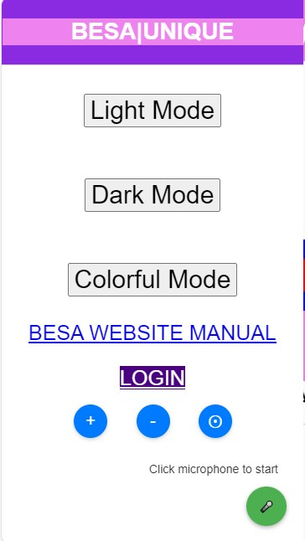
WEBSITE MANUAL
GET INFORMATION ABOUT THE FEAUTURES OF THE WEBSITE. CLICK TO DOWNLOAD IT AND HAVE ACCESS TO IT
VOICE COMMAND
USED TO MOVE FROM ONE WEBPAGE TO ANOTHER USING YOUR VOICE BY CLICKING ON IT AND ALLOWING IT
ZOOM NORMAL
ZOOMS THE WEBSITE FONTS SIZE TO ITS ORIGINAL FONT SIZE
ZOOM IN
USED TO INCREASE THE FONT SIZE OF THE WEBSITE
ZOOM OUT
USED TO DECREASE THE FONT SIZE OF THE WEBSITE
WEBPAGE MODES
YOU CAN USE THEM BY CLICKING ON THEM.

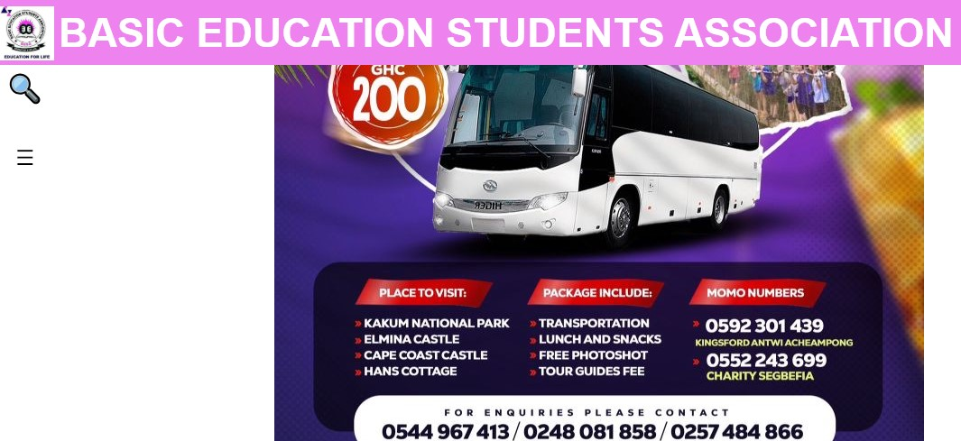
TOGGLE SIDEBAR:
CLICK ON THE BUTTON TO TOGGLE THE SIDEBAR

ALL TEXTS ARE ZOOMABLE, JUST USE THE ZOOM CONTROL BUTTONS IN THE PREVIOUS PAGE.
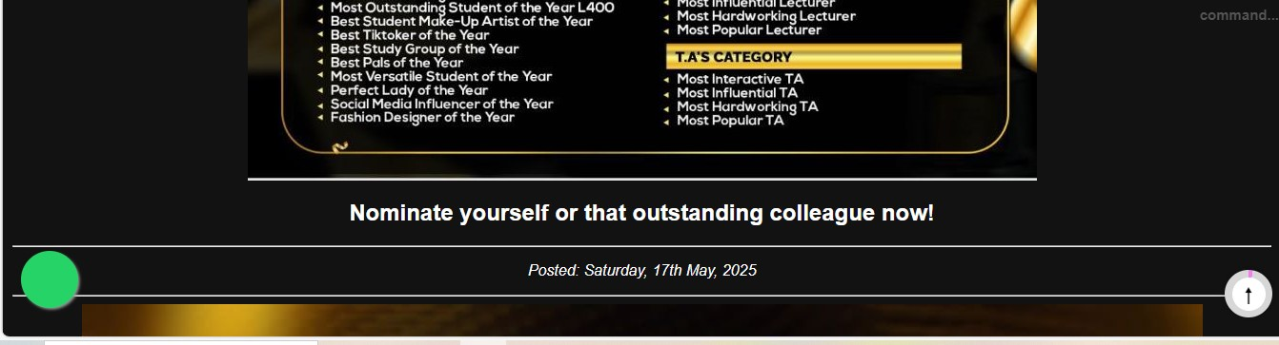

YOU CAN SHARE THE WEBSITE LINK TO ALL THE SOCIAL MEDIA HANDLES BY JUST CLICKING ON THEM AND SHARING THEM.
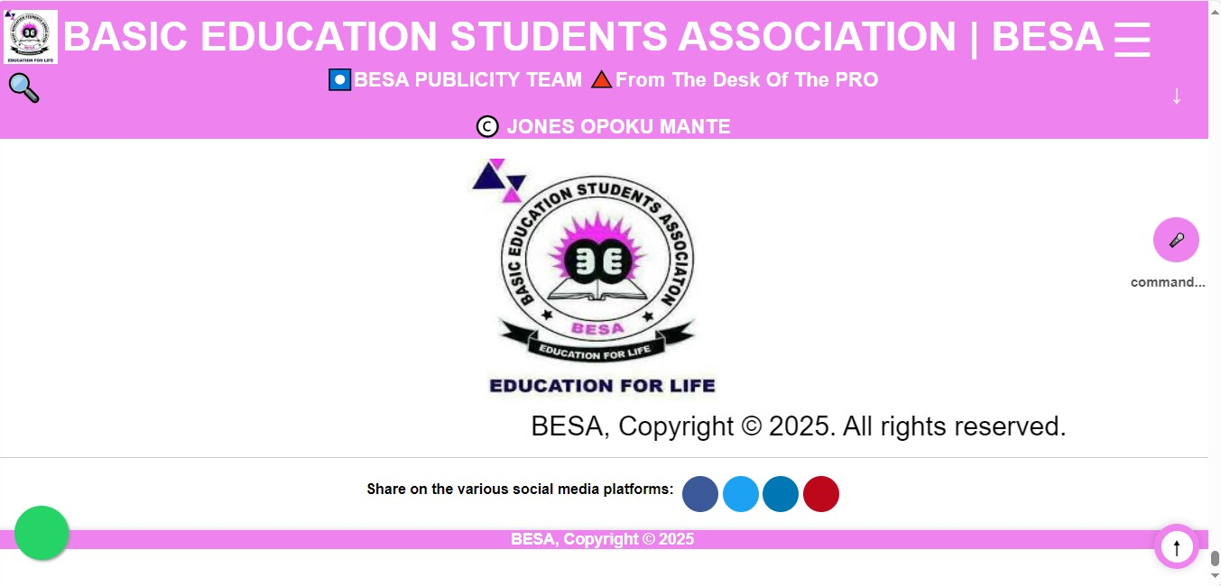

YOU CAN ACCESS THESE WEBSITES RIGHT HERE. JUST SCROLL DOWN TO THE BOTTOM, THEN SCROLL UP A LITTLE BIT, TO ACCESS THEM.
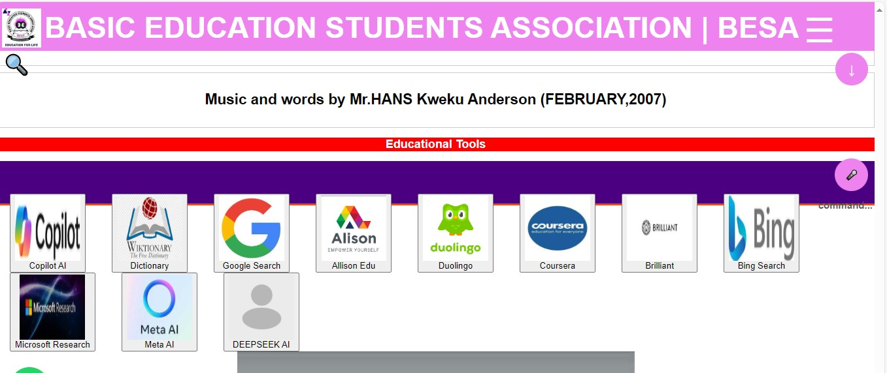

MOVE TO THE BESA RESOURCES PAGE TO VIEW A GALLERY FILLED CONTENT OF THE DEPARTMENT. WHEN YOU LICK ON AN IMAGE, YOU CAN VIEW ITS FEATURES. Swipe left or right to move to next image.
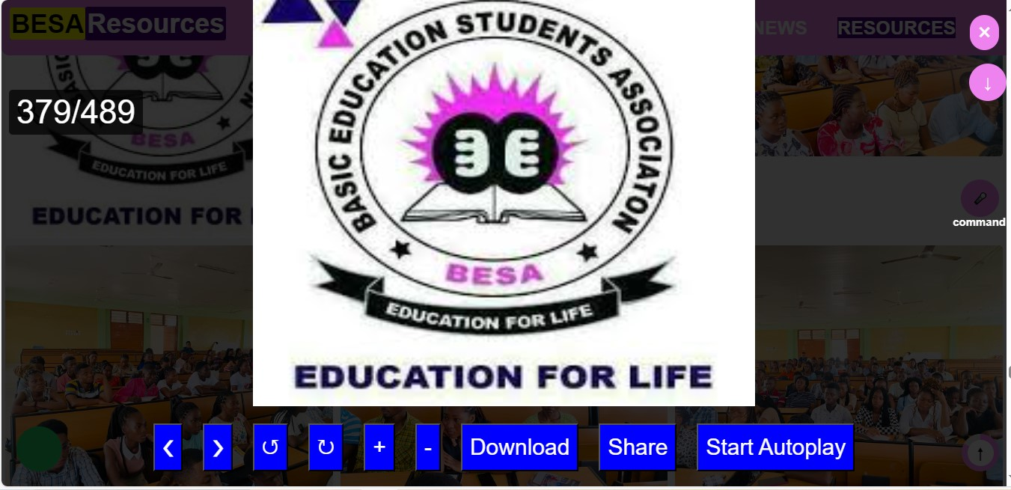
+ (ZOOM IN), - (ZOOM OUT)
CLICK TO (DOWNLOAD IMAGE)
CLICK TO SHARE IMAGE
AUTOPLAY IMAGES, CLICK ON IT

CLOSE IMAGE
CLOSE ANY OPENED IMAGE.
< (PREVIOUS IMAGE)
> (NEXT IMAGE)
↺ (ROTATE)
↻ (ROTATE)

IMAGE COUNTER
VIEW THE TOTAL NUMBER OF IMAGES UPLOADED INTO THE GALLERY

ACCESS DOCUMENTS HERE. VISIT THE BESA RESOURCES WEBPAGE, SCROLL DOWN TO ACCESS THE VARIOUS DOCUMENTS.
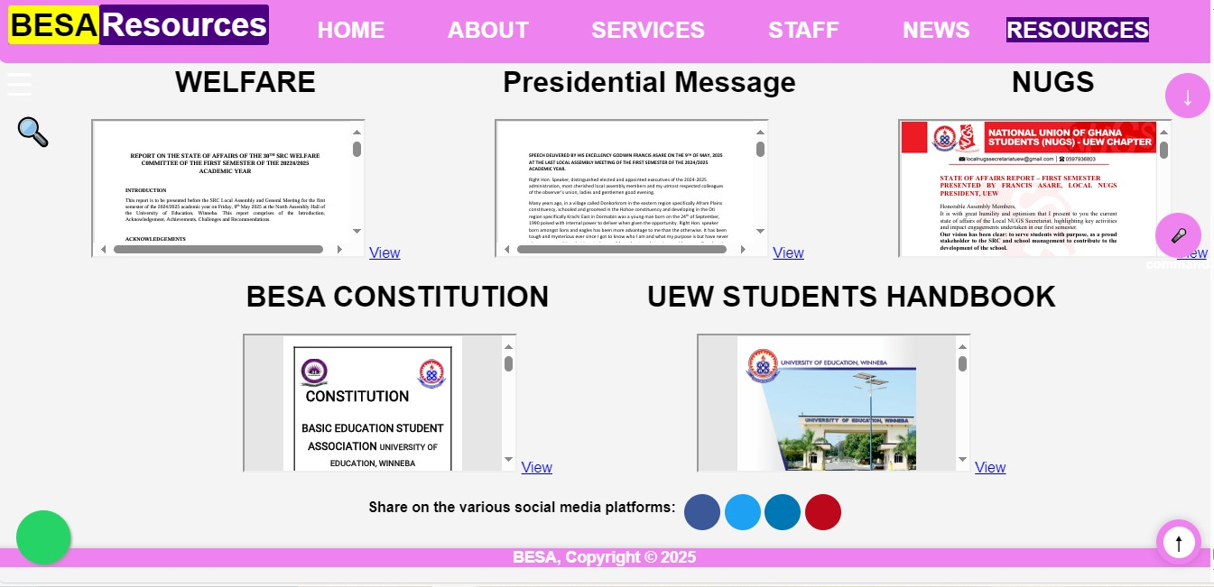

THANKS BE TO GOD ALMIGHTY FOR THE SUCCESS OF THIS DOCUMENT

